Nested Table Example 2: Step-by-Step Explanation with Visuals
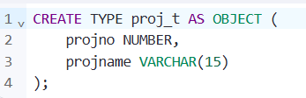
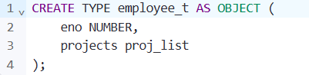
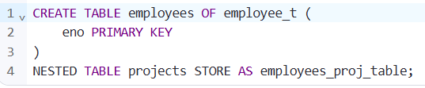
1. Inserting a Row into the employees Table
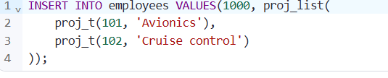
Use the TABLE(...) function to flatten the nested table and query it like a regular table.
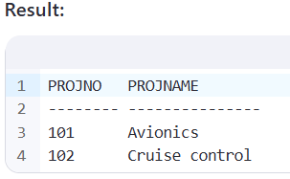

- Unnest or Flatten a Nested Table:
  - Collection unnesting involves "flattening" a nested table by joining each row of the nested table with the row that contains it.
  - This operation is useful for querying individual elements of a nested collection in a relational way.
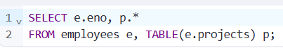
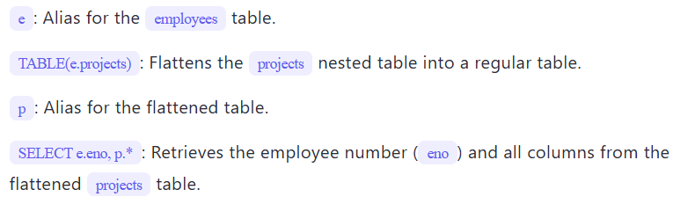
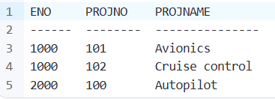
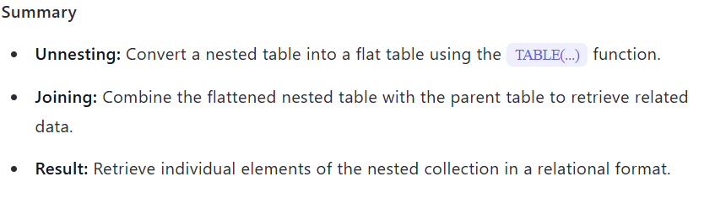
DML Operations on Nested Tables
Let’s break down how to perform Data Manipulation Language (DML) operations (INSERT, UPDATE, DELETE) on nested tables using the provided examples and clear visuals.
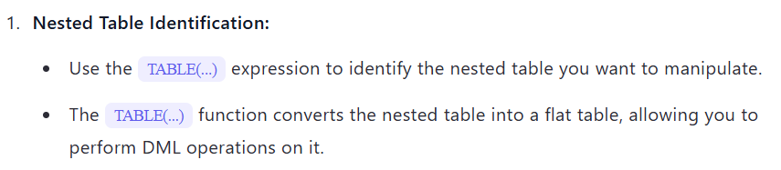
- DML Operations:
  - INSERT: Add new rows to the nested table.
  - UPDATE: Modify existing rows in the nested table.
  - DELETE: Remove rows from the nested table.

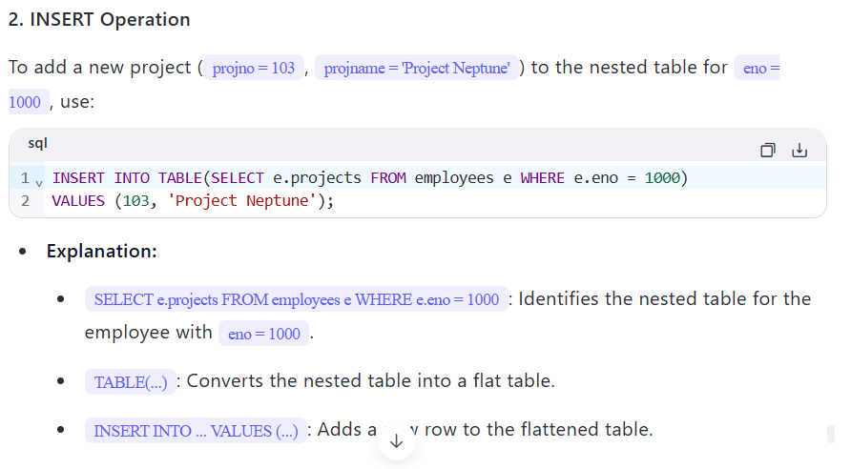
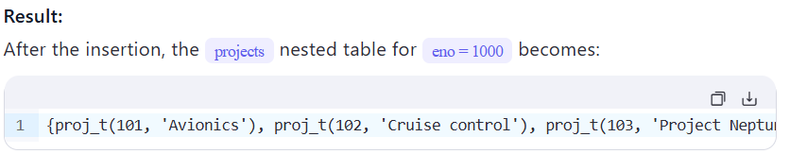

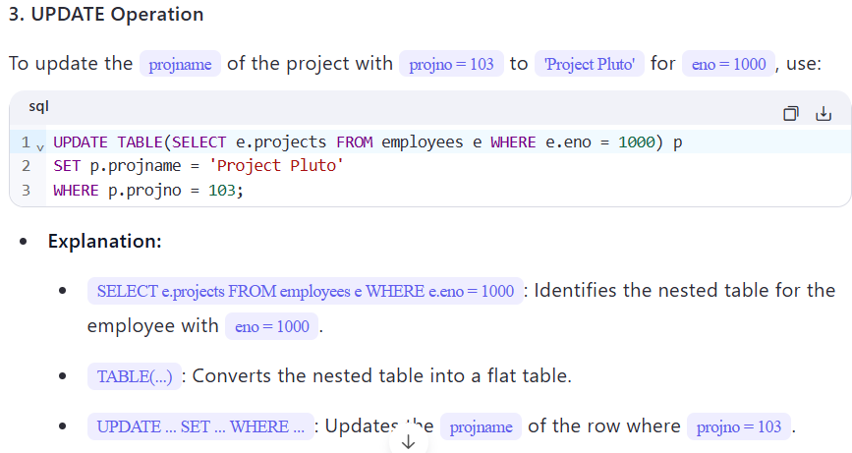
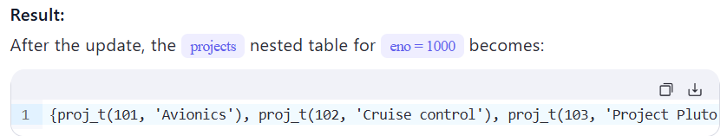
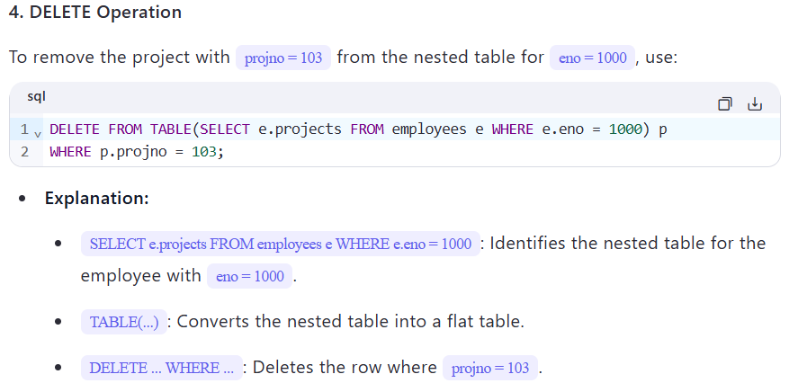
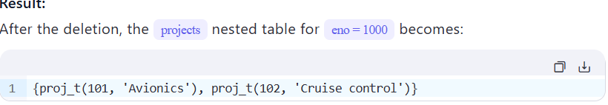

- Dropping a Nested Table: Set the nested table column to NULL using an UPDATE statement.
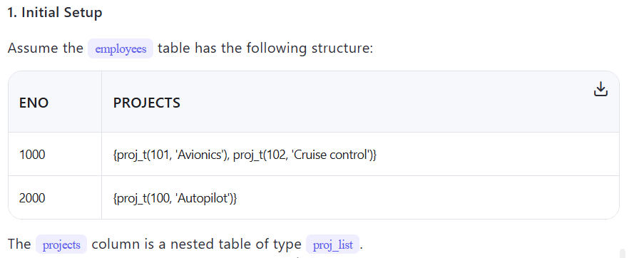

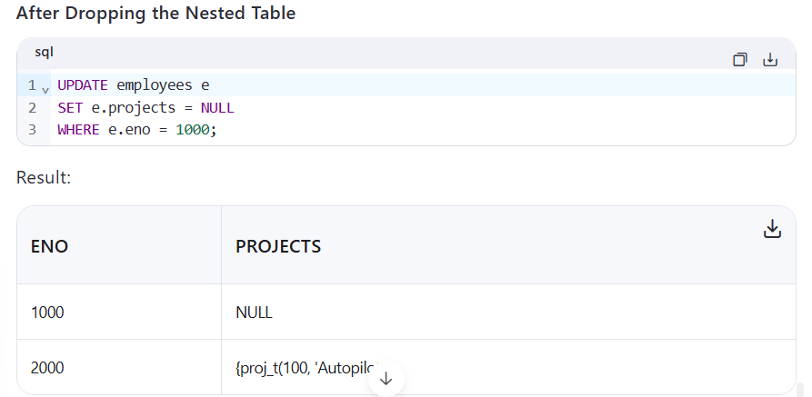
- Adding Back a Nested Table Row: Update the nested table column with a new value using the proj_list constructor.
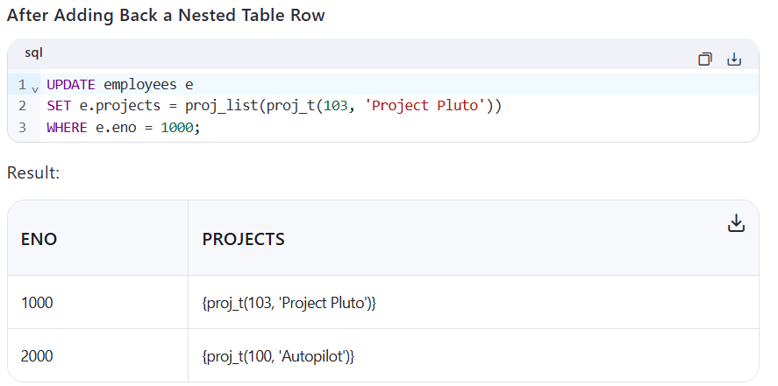
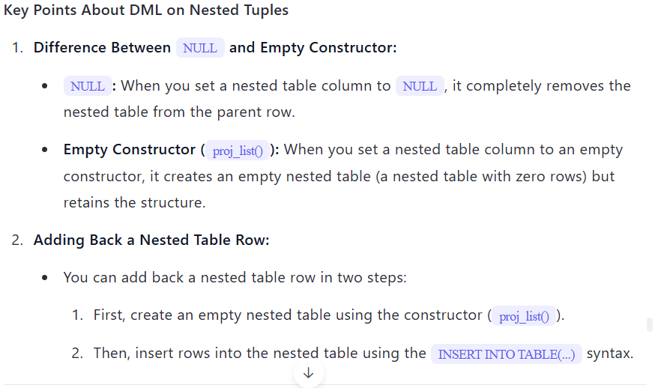

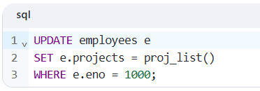
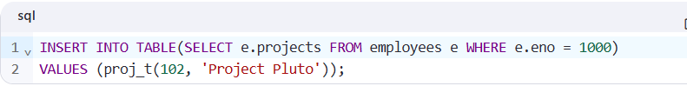
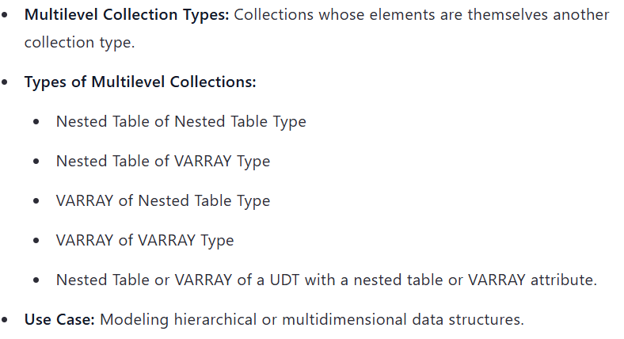

Multilevel Collection Types Example
